Move Files Manually Between Instances (& Local Machine)

Use the File Zilla application to move files between remote instance and your local computer. (Or you could do between 2 instances, but this example is just between remote & local.)

1. Open up File Zilla
2. File > Site Manager
   1. “New Site” Button
   2. Select SFTP protocol
   3. Paste in the Host (Public IP address)
   4. Logon type = Key File
   5. User: “ubuntu”
   6. Upload the correct key file
   7. 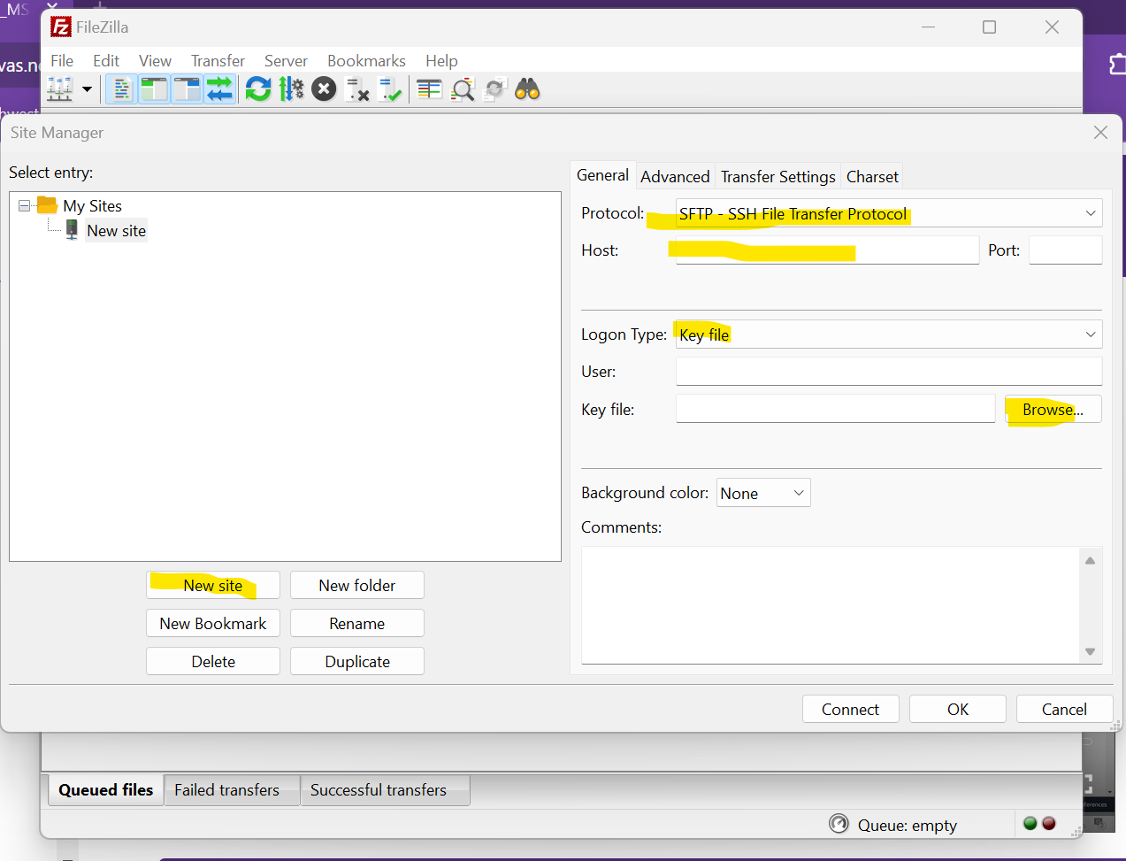
3. Connect, Establish connection in a new tab